Lesson 3.3: CO2 and Sea Level Rise/Coastal Erosion

Location: Classroom  Grade Level: High School  Time: Two class sessions of 50 minutes  Driving Questions  - How does increased carbon dioxide in the atmosphere cause sea level rise?  - How do sea level rise and coastal erosion affect access to the ocean? | Lesson Synopsis  During this lesson, students investigate how rising atmospheric carbon dioxide is a catalyst that can lead to sea level rise and coastal erosion through changes in other processes, such as global warming and frequency and intensity of storms. They also explore how these changes can affect how their community holds value in Southern California’s ocean.  On day one, students begin to connect their understanding of weather pattern changes due to increased carbon dioxide emissions in the atmosphere to global warming, and the impacts that global warming can have on melting ice caps and the thermal expansion of water, causing sea levels to rise.  On day two, students explore the Our Coast Our Future simulation tool to explore different scenarios of sea level rise, shoreline positions, and cliff retreat across Southern California’s Ocean. They then compare the potential impacts of different projected scenarios and reflect on how the increase to carbon dioxide in the atmosphere can lead to limited access to the ocean,  Students finally reflect how they may modify their model to incorporate their newfound knowledge.  What students will figure out:  - Rising atmospheric CO2 drives global warming, which in turn contributes to melting ice caps and the thermal expansion of ocean water, leading to sea level rise.  - Sea level rise and more frequent storms can accelerate coastal erosion and change shoreline positions, threatening access to and uses of Southern California’s coast.  - Human-caused changes to the carbon cycle affect both natural systems and community values.

LEARNING OUTCOMES

By the end of this investigation, students will be able to… | You can assess this using…
- Explain how an increase in atmospheric carbon dioxide contributes to sea level rise and coastal erosion | Group discussion in the Navigate section
- Analyze sea level rise and coastal erosion data to identify potential local impacts on Southern California’s ocean | Using Our Coast Our Future tool in the Investigate section
- Plan how they will update their SageModeler models with their newfound information of sea level rise and coastal erosion | Group discussing in the Navigate section
- Reflect on how changes to sea level and coastal erosion rates can affect human access and use of coastal environments | Group reflection in the Navigate and Problematize sections

Building towards NGSS and AI Literacy:
- HS-ESS3-6: Use a computational representation to illustrate the relationships among Earth systems and how those relationships are being modified due to human activity. In this lesson, students will construct a model based on local climate change and how human activity contributes to positive and negative effects in the environment.

Lesson Overview (2 sessions)
This lesson includes a shared teacher-led introduction with Lesson 3.4 Ocean Acidification and then transitions into the student-led portions.

Teacher Led Portion Day 1: What do we Want to Learn More About? (10 minutes)
Section | Time | What Happens
Navigate | 10 minutes | This is a teacher-led section of the program that gets the class started for Lessons 3.3 or 3.4.  Students begin by reflecting back on how increased levels of carbon dioxide emissions lead to changing weather and how that can lead to an increased rate of global warming.

Student Led Lesson Day 1: Exploring the Causes of Sea Level Rise (40 minutes)
Section | Time | What Happens
Navigate | 5 minutes | Students begin the investigation by exploring a high tide event caused by a king tide at Alamitos Bay in Long Beach, California and brainstorm what they think is causing the water to be so close to property on the coastline.
Investigate | 25 minutes | To investigate this phenomenon, students apply their understanding of carbon dioxide’s impact on the global temperature to create an initial drawn model of what they think is causing the water’s level to get so high.  They then watch a video that highlights two main causes of sea level rise, melting ice caps and the thermal expansion of ocean sea water, both caused as a result of global temperatures increasing.  Students then return to their drawn model and update it with the ideas they learn from in the video, connecting human carbon emissions to increasing sea levels.
Navigate | 5 minutes | As a class, students come together to explain what they did and what they observed during day one of their observations. Students also share initial ideas of how they can build their understanding of carbon dioxide’s role within their investigation.
Problematize | 5 minutes | Students reflect on what causes sea levels to rise and then brainstorm how they may learn more about sea level rise’s impact on coastal communities in Southern California.

Student Led Lesson Day 2: Exploring Sea Level Rise’s Impact on Coastal Communities (50 minutes)
Section | Time | What Happens
Navigate | 5 minutes | Students begin the investigation by revisiting the image sharing a high tide event caused by a king tide at Alamitos Bay in Long Beach, California. Building off of their understanding from day one, they share new insights they have.
Investigate | 30 minutes | Now that students have explored what causes sea level rise to happen, during day two, students explore what impacts sea level rise has on coastal communities.  Students do this by exploring a simulation tool called Our Coast Our Future to explore sea level rise scenarios using projections for 2050 and 2100. They then explore how these projections impact flooding in the Alamitos Bay community and the shoreline position of Alamitos Beach.
Navigate | 10 minutes | Once students have gained knowledge about what causes sea level rise and how sea level rise impacts coastal communities in Southern California, they work together to create a plan to update their SageModeler model from Module 2 with their newfound knowledge.
Problematize | 5 minutes | Students work in teams to reflect on the day’s investigations, discussing how their thinking has changed and what updates they plan to make to their SageModeler models in the next lesson. They prepare to apply their new insights to strengthen their models in the upcoming session.

MATERIALS
- Lesson 3.3/3.4 Introduction Slideshow - Students select either lesson 3.3 or 3.4
  - Lesson 3.3 Slideshow
- Science Journal
- Our Coast Our Future Instruction Sheet (also provided in Science Journal p. 36-43)

BEFORE YOU START TEACHING
- For Lesson 3.3, review Student Our Coast Our Future Instructions (also in Science Journal, p. 36-43) to model or support students. Explore Our Coast Our Future Website.

- Include a numbered list of general steps to set up the investigation before students arrive.

WHERE WE ARE GOING AND NOT GOING
Where We Are Going: In this lesson, students are deepening their understanding of how rising atmospheric carbon dioxide acts as a catalyst for interconnected Earth processes, specifically how global warming leads to melting ice, thermal expansion of seawater, and ultimately sea level rise and coastal erosion. They will use simulation tools to visualize these changes along Southern California’s coastline and consider how such environmental shifts can affect community values, ocean access, and coastal ecosystems. The focus is on connecting scientific cause-effect relationships to local, human-centered impacts.

Where We Are NOT Going: This lesson does not aim to cover the detailed physics or mathematical modeling behind climate simulations. Students will not analyze global datasets in depth or evaluate specific mitigation policies.

LEARNING SEQUENCE
Lesson plan notes are also provided on the slide notes.

NAVIGATE: Reflect (10 minutes)
Lesson 3.3/3.4 Introduction Slides
- Open the introduction slideshow to Slide 1 and welcome students into the class and tell them that today, they will continue to learn about how carbon dioxide can change the rate of natural processes and affect the values that they care about.

- Advance the slideshow to Slide 2 and ask the class to take a moment and reflect on what they learned in lesson 3.2.
  - How did an increase of carbon dioxide emissions impact processes like global warming?
  - How do these changes affect the values your group placed on the ocean in your model?

As students share, emphasize and elevate ideas that include mention that increased levels of carbon dioxide emissions have an impact on the rate of change of global processes like global warming.

- After student teams have reflected on the previous lesson, inform them that their next step is to find out what other processes might be impacted by increased carbon dioxide emissions.

- Gather students in their teams from Module 2 and advance to Slide 3. Invite students to look at their team’s model and brainstorm other processes that may be impacted by increased carbon dioxide emissions.
- How may increased carbon dioxide emissions impact other processes that you have included in your team’s model?

- As students discuss with their teams, walk around and listen for conversations where you may support the student's brainstorming. Ask questions to guide students to choosing processes that we will investigate in lessons 3.3 and 3.4, sea level rise, coastal erosion, ocean acidification, and food web impacts.
  - What processes in your model have a large impact on the value your community cares about?
  - How might we investigate this process further?

- After student teams have had a chance to review their models, invite the class back together to share some of their ideas.

- Advance to Slide 4 and tell students that for the next two sessions, they will embark on a student-led lesson, where they will learn more about particular processes that impact the value that their model centers on and ultimately update their team’s model with their newfound information. They will have two options.
  - Option 1: Sea level rise and coastal erosion - You may choose this path if your model centers around the values of mental health and wellbeing, recreation, financial, and biodiversity.
  - Option 2: Ocean acidification and food web - You may choose this path if your model centers around the values of seafood, tradition, biodiversity, and cultural significance.

To help guide students to choose their option, ask students the following question:
- Of the two options provided, which processes might affect the value that centers your model the most?

- When students are ready, have them choose which investigation fits best with the value their community places on the Ocean.
  - Lesson 3.3 - Sea Level Rise and Coastal Erosion
  - Lesson 3.4 - Ocean Acidification

DAY 1: NAVIGATE (5 minutes): Exploring Sea Level Rise in their Community
Lesson plan notes are also provided on the slide notes.

Lesson 3.3 Slideshow: CO₂ & Sea Level Rise/ Coastal Erosion
- Open Lesson 3.3 slideshow to Slide 1 where students will see a notice that this lesson is a student-led lesson, meaning that they will move through it with their team within the next two sessions.

- Move on to Slide 2 where students will see the two-day overview for module 3.3.

- When student teams are ready, advance to Slide 3 where they will see an image of houses by the coast. Students are then asked to take 5 minutes to discuss with their group and answer the following questions:

  - What do you think is happening in this image?
  - Is what you are observing a natural occurrence? How often does this happen?
  - Why might communities want to understand this scenario?
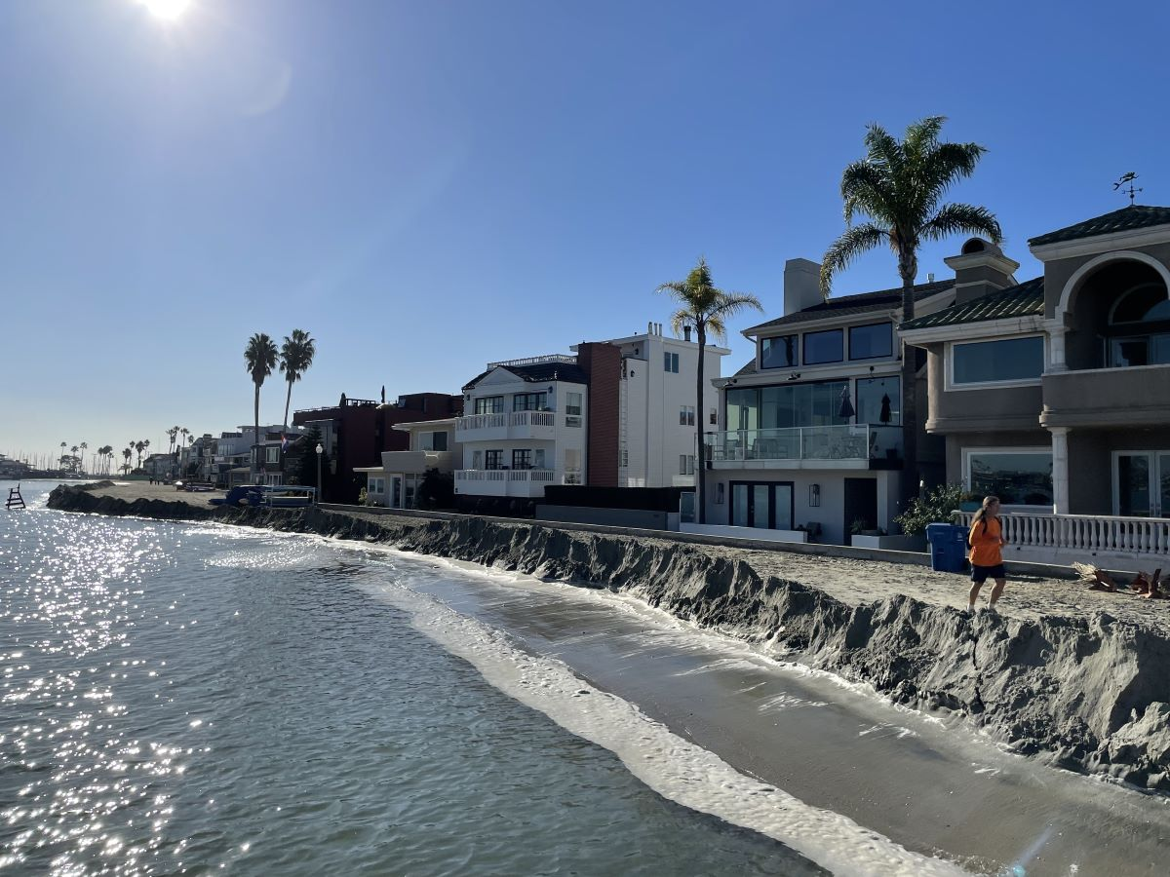

- Gather the students as a class and ask students to share their responses with the class. At this point it is not important for them to be accurate with responses; you just want to gauge what they are noticing

- After students have shared, have them advance to Slide 4 where more information is shared with the students.

The image shows a king tide event at Alamitos Bay, in Long Beach California on November 16, 2024. King tide events are the most extreme of low tide and high tides that happen within a couple of days, which happen once or twice a year. Though they do not happen often, they give us a glimpse as to what our future coastlines may look like.

- Advance to Slide 5 where students will be told that over the next two lessons, they will investigate sea level rise, its causes, and how it can impact coastal accessibility for communities. They will do so by investigating how global warming is connected to sea level rise and look at simulations for predictions for the future.

DAY 1: INVESTIGATE: Building Understanding - The Impact of Global Warming on Ice Caps and Thermal Expansion of Water (25 minutes)

- Have students advance to Slide 6 and share that first, in their teams, you would like them to create a drawn model on what they think is causing sea level rise. Here students will see instructions to help guide them through the model.

- Using a poster paper, draw what is contributing to sea level rise.
- Remember to label the components of your model and explain processes that are happening, for example, “Component A interacts with Component B, causing [what happens]”

- Give student teams 10 minutes to model their explanation of what is causing sea level rise. As they work, walk around and support the students in reflecting back to what they have learned in previous lessons that might help their explanation.

- What in your model is directly impacting sea levels?
- Do you think there are any human impacts that might indirectly affect sea levels?

- Once students start wrapping up their initial model, have them advance to Slide 7, where they will be asked to watch a short video, What Causes Sea Level Rise? [2:43], which will help them expand their models.

- As students watch the video, they will be asked to think of the following:

  - What are you observing in the video that you would like to add to your team’s model?
  - How are humans contributing to the sea level rise process?
  - How will sea levels impact communities that value Southern California’s Ocean?

- Once students have watched the video, advance to Slide 8 and have them revisit their team’s model to revise it with their newfound knowledge.

  - What processes or components did you learn about in the video that you would like to add to your model?
  - How does sea level rise impact communities that value Southern California’s Ocean? How can that be shown in our team’s model?

DAY 1: NAVIGATE: Sharing What We’ve Learned (5 minutes)
- As you reach the end of the class period, bring the students back together for a class conversation (See Module 3.3 & 3.4 Introduction Slides, Slide 5). As not all students did the exact same activity, get at least one student from each exploration to share responses to the following questions with the class.
  - What did you do today?
  - What were some of the most surprising findings you gained from today?

- As students share their experiences, ask the following questions:

  - What specific data do you think is still missing to further your understanding?
    - What might help strengthen your understanding of carbon dioxide’s impact on sea level rise?
    - What might help strengthen your understanding of carbon dioxide’s impact on ocean acidification?
  - Where might you collect this data?

DAY 1: PROBLEMATIZE: Reflecting on the Day (5 minutes)
- As students wrap up for the day, send groups back to their Module 3.3 slides to reflect on the process of creating a model for sea level rise.

- Advance to Slide 9 and have student teams work together to answer the following questions together on Module 3.3: CO2 and Sea Level Rise/Coastal Erosion (Day 1: Investigating Sea Level Rise Student Reflection). p. 35 of their Science Journals.

- How has your thinking about what causes sea level rise changed? Think about new ideas or surprises you noticed while creating or revising your model.
- How could sea level rise impact communities and things they value about the Southern California ocean?
- Which parts of your model do you still have questions about?

- Thank students for their participation today and inform them that in the next session, they will continue to learn more about sea level rise, but through scientific simulations!

DAY 2: NAVIGATE (5 minutes): Further Exploring Sea Level Rise
- Welcome students back for day two of their sea level rise investigation. Have students open the slideshow to Slide 10, where day two starts.

- When student teams are ready, advance to Slide 11 where they will see the same image from Long Beach on Day 1 to see how their thinking has changed. As a group, answer the following questions.

Now that you have gained more information about sea level rise, let's revisit this image.
  - What do you think is happening in this image? Why is it happening?
  - Is what you are observing a natural occurrence? How often does this happen?
  - Why might communities want to understand this scenario?


- Have students share with their group and then when they are ready, they can advance to Slide 12 where they will see their goal for today.

- Today, you will further investigate how sea level rise is affecting communities through exploring scientific sea level rise simulations and use the information you gather to plan how you want to update your SageModeler model to describe how ocean acidification impacts the values your community places on Southern California’s ocean.

DAY 2: INVESTIGATE: Our Coast Our Future Simulation (30 minutes)
- As students advance to Slide 13 they will see the simulation tool they will use to further investigate sea level rise, Our Coast Our Future, along with some tasks for the day.
  - As a team, you will investigate the Our Coast Our Future simulation tool to explore sea level rise impact predictions.
  - On Module 3.3 Impacts of Sea Level Rise on Coastal Communities Our Coast Our Future (p.36) of your Science Journal, you will have scenarios to investigate and questions to answer. Work as a team to answer these questions.

- Once students are ready, have them open their Science Journals to Module 3.3 Impact of Sea Level Rise on Flooding in Alamitos Bay Our Coast Our Future where they will track their findings during their investigation.

- When students are ready, have them open the Our Coast Our Future platform and locate Alamitos Bay in Long Beach. They will focus on exploring two different scenarios:
  - Sea level rise’s impact on flooding in Alamitos Bay
  - Sea level rise’s impact on shoreline position on Alamitos Beach

- As students navigate through the Our Coast Our Future platform, walk around the group and provide support and ask questions to guide their investigation. Examples include:

  - What impact is the sea level rise projection for 2050 having on the Alamitos Bay community? How can you tell?
  - How does the shoreline position differ on Alamitos Beach with the projections for sea level rise for 2050 and 2100?

- If time allows as students investigate the platform, invite them to search another coast that they might be familiar with to see if the sea level impact is similar or different between these locations.
- How does sea level rise impact these locations differently? How does it impact them similarly?

DAY 2: NAVIGATE: Discuss How to Update our Models (10 minutes)
- As students wrap up their investigation, advance to Slide 14 and tell students that their next step is to create a plan to update their SageModeler model from Module 2 with their newfound knowledge during their investigation.

- Have students open their Science Journal to Module 3.3: Impacts of Sea Level Rise on Coastal Communities (Planning to Update Our SageModler Model) (p.44), where they will have a table to help them think through their updates. As students work together, walk around the groups and support them in answering the questions.
  - What investigation did you take part in?
  - How did your thinking change as a result of this investigation? What new information did you learn?
  - What do you want to add, remove, or update in your SageModeler model?

Students may need support in thinking about how to expand their original model, invite students to take a look back at their materials from module 3 so far and look at what components they investigated.

Some options may include:
- For all investigations: carbon dioxide emissions and atmospheric carbon dioxide.
- For sea level rise and coastal erosion investigations: melting land ice, shoreline width, or flooding
- For ocean acidification investigations: ocean pH levels, organisms with calcium carbonate shells, or connections back to the food chain that impacts their value, for example, availability of fish.

- Once students have created their plan, bring the class back together (See Module 3.3 & 3.4 Introduction Slides, Slide 6) and have them share out with the class if time permits. Since different students will have different investigations and their models share different values, focus on the following questions:

  - What value does your SageModeler model center on?
  - What investigation did you take part in? (sea level rise or ocean acidification)’
  - How do you want to update your SageModeler model as a result of your investigation? How does this impact connect with the value your model centers?

DAY 2: PROBLEMATIZE: Reflecting on the Day (5 minutes)
- As students wrap up for the day, their final task for the day is to reflect on what they did.

- Advance to Slide 15 and have student teams work together to answer the following questions together on Module 3.3: CO2 and Sea Level Rise/Coastal Erosion (Day 2: Investigating Sea Level Rise Student Reflection), p. 37 of their Science Journals.
- What new information or evidence changed your thinking about what causes sea level rise or how it affects communities?
- What questions do you still have about sea level rise?
- What updates do you plan to make to your SageModeler in the next lesson to strengthen your model?
- Thank students for their participation today and inform them that in the next session, they will come back to their SageModeler model and update it with their newfound knowledge from their investigations.

